https://learn.adafruit.com/adafruit-agc-electret-microphone-amplifier-max9814/wiring-and-test

**Wiring and Test**

[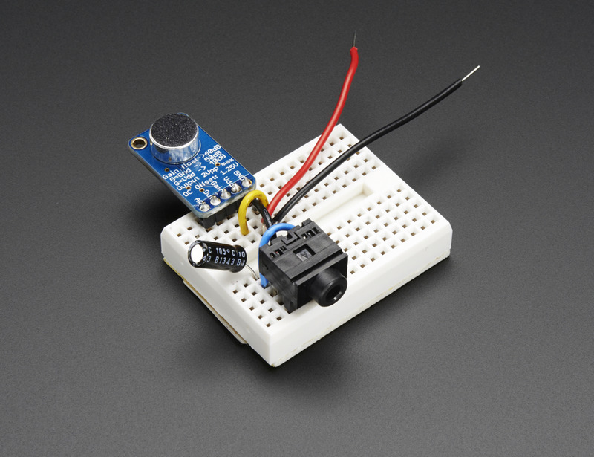](https://learn.adafruit.com/assets/14302)

The microphone amp is thankfully quite simple to get started. No microcontroller or programming required. We suggest wiring it up directly with a battery pack and headphones to start while you get a hang of how the AGC acts and responds.  
  
You'll need a [3 AA/AAA battery pack](https://www.adafruit.com/products/727) (or some external source of 3-5VDC) - we suggest batteries since they are very electrically-quiet compared to USB or wall power adapters.

(For rechargeable NiMH cells, you can use a 4xAA/AAA pack for a total of 4.8v)  
  
You'll also need [a headphone jack, this breadboard-friendly one](https://www.adafruit.com/products/1699) works great, and a 1 to 100uF electrolytic capacitor. This is just to protect your headphones from the DC bias voltage. Just about any capacitor will work.   
  
Find the 'cheapest' headphones you have, or use earbuds, they wont load down the microphone amp as much! This is not a good time to use your huge Sennheiser cans. Don't connect to speakers or you will get really horrible feedback effects

**Wiring**

[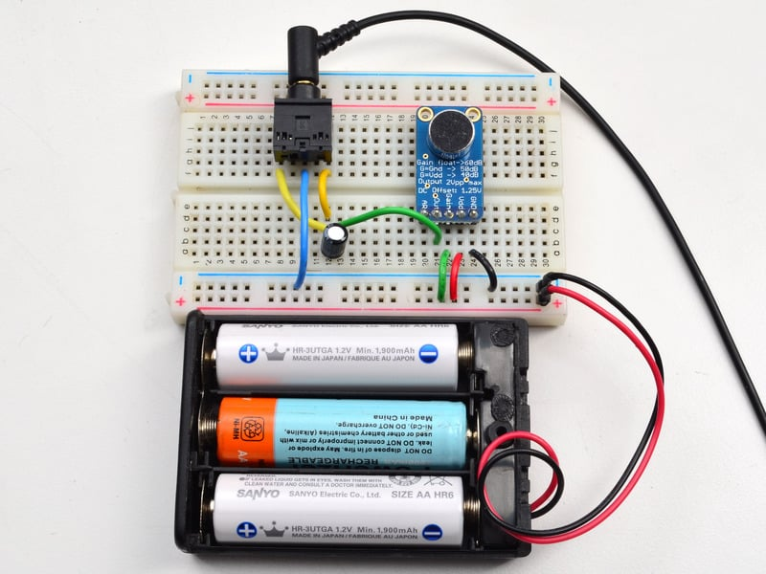](https://learn.adafruit.com/assets/14296)

Connect the amplifier, battery pack and headphone jack as shown above.  
  
For the Microphone amp:

* **GND** connects to the battery pack ground - black wire
* **VDD** connects to the battery pack positive - red wire
* Connect the **Gain** pin to VDD for now - green wire
* Connect the **OUT** pin to a 1uF-100uF capacitor (really any value will do). If the capacitor is polarized, connect the OUT pin to the positive side - green wire

For the headphone jack

* Connect the **Left** and **Right** pins together (the microphone is mono out) to the negative side of the capacitor - yellow wires.
* Connect the center ground pin to the battery ground - blue wire

**Test!**

Now try listening to sounds on the headphones, you should notice a strange 'effect' where you can hear people from further away than your hearing is used to! Try setting the **Gain** pin to the GND pin to get 10dB more gain. You can also remove the Gain wire, to set the gain to 60dB but you may find the gain is way too high, and it sounds 'too noisy', so we suggest sticking to 40 or 50dB for most purposes.  
  
You can also try adjusting the A/R (attack/response) ratio by connecting the A/R pin to VDD or GND but we found that the default no-wire works pretty well for most purposes.

**Do more!**

Now that you have the amplifier tested, you can use this microphone amp just like our non-AGC board.  
  
Check out <http://learn.adafruit.com/adafruit-microphone-amplifier-breakout/measuring-sound-levels> and <http://learn.adafruit.com/adafruit-microphone-amplifier-breakout/more-cool-projects> for other projects that can be adapted to use this amplifier.